**Object Oriented Programming Coursework for Endterm: Otodecks**

Name – Rishi Sankhla

Student No. – **200102874**

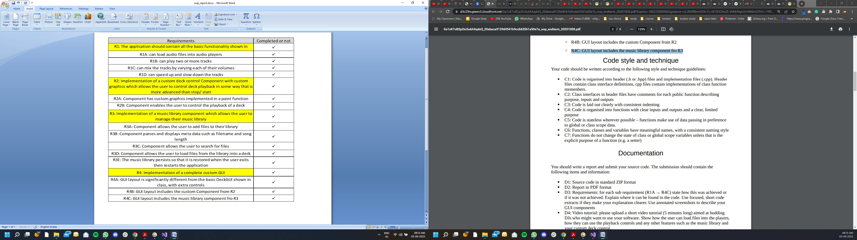

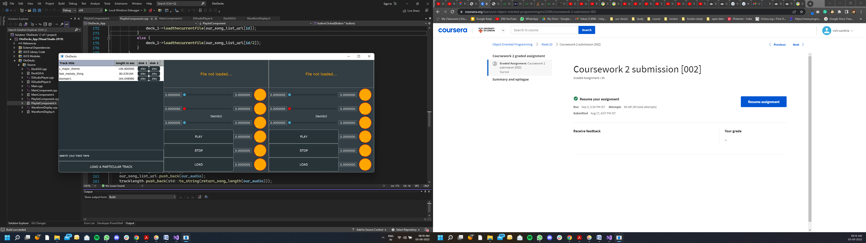

R1A: yes user can directly load audio file into the deck, through load button. As we can see in the screenshot below.

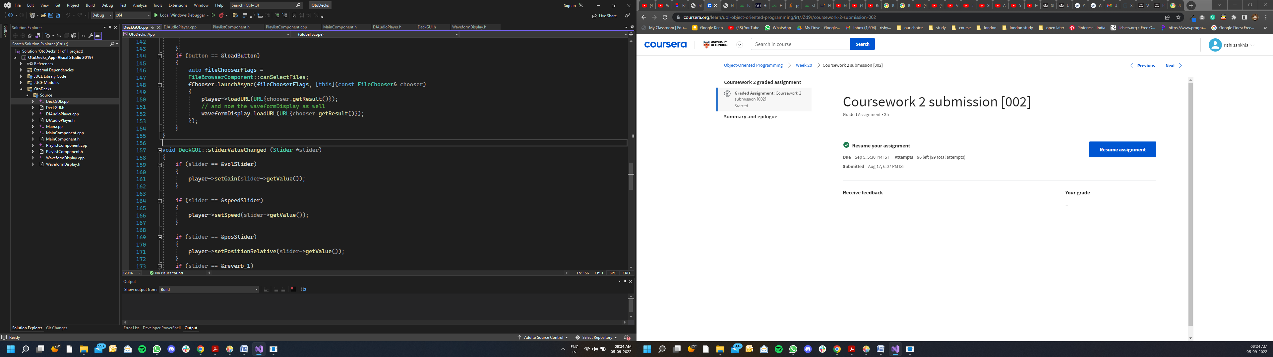

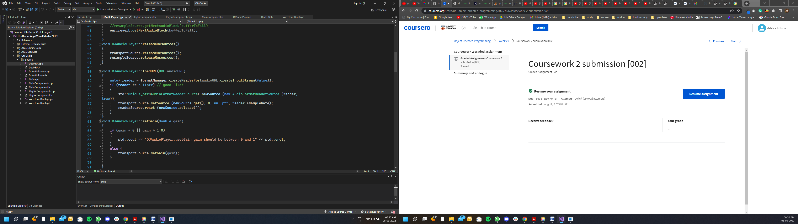

Here we can see in the deckGUI.cpp file that Whenever user clicks the load button it opens the file browser component and pass the URL link to the appropriate player deck.

R1B: yes user can play two or more tracks, by clicking the play button. It activates the start function of the appropriate player DJAudiofile class. Which calls the start function of transportSource layer. (refer below screenshots)

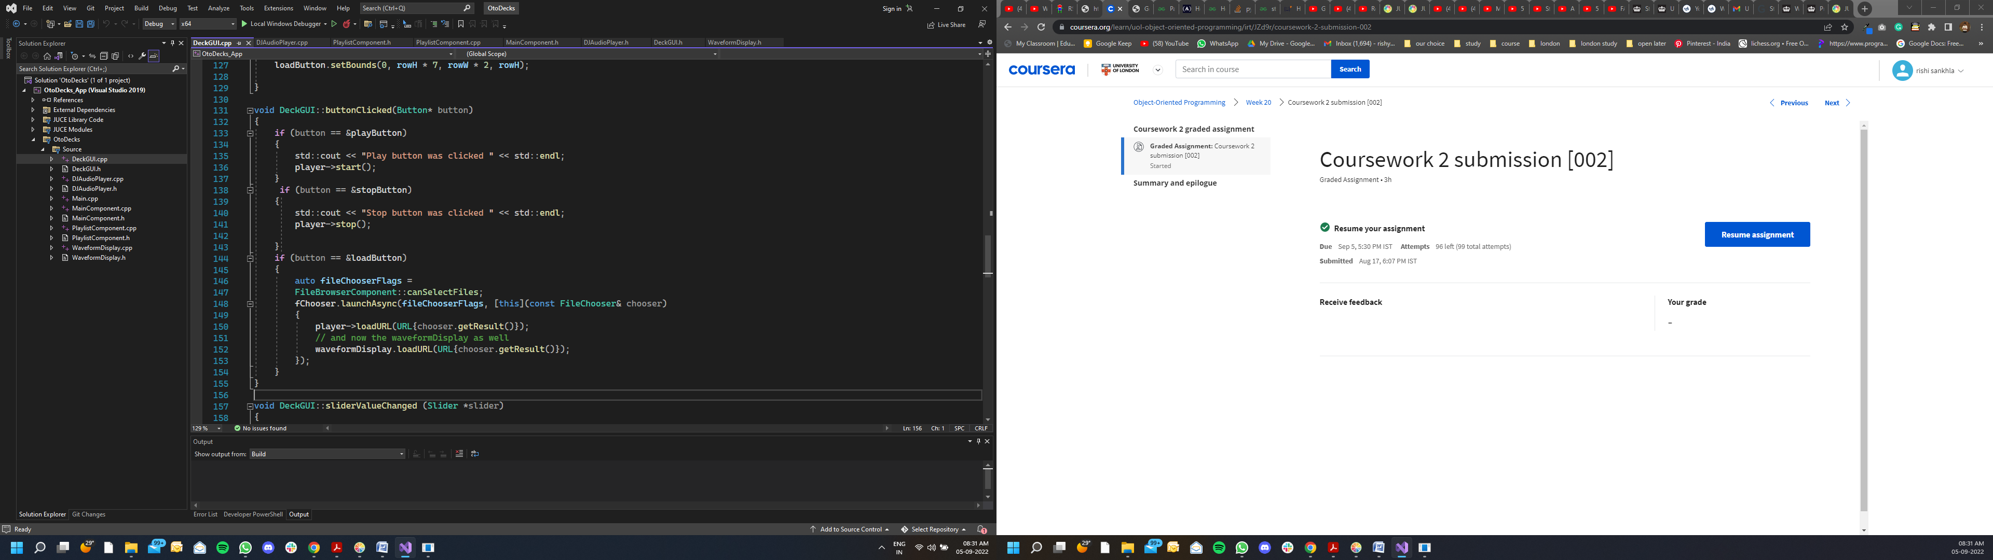

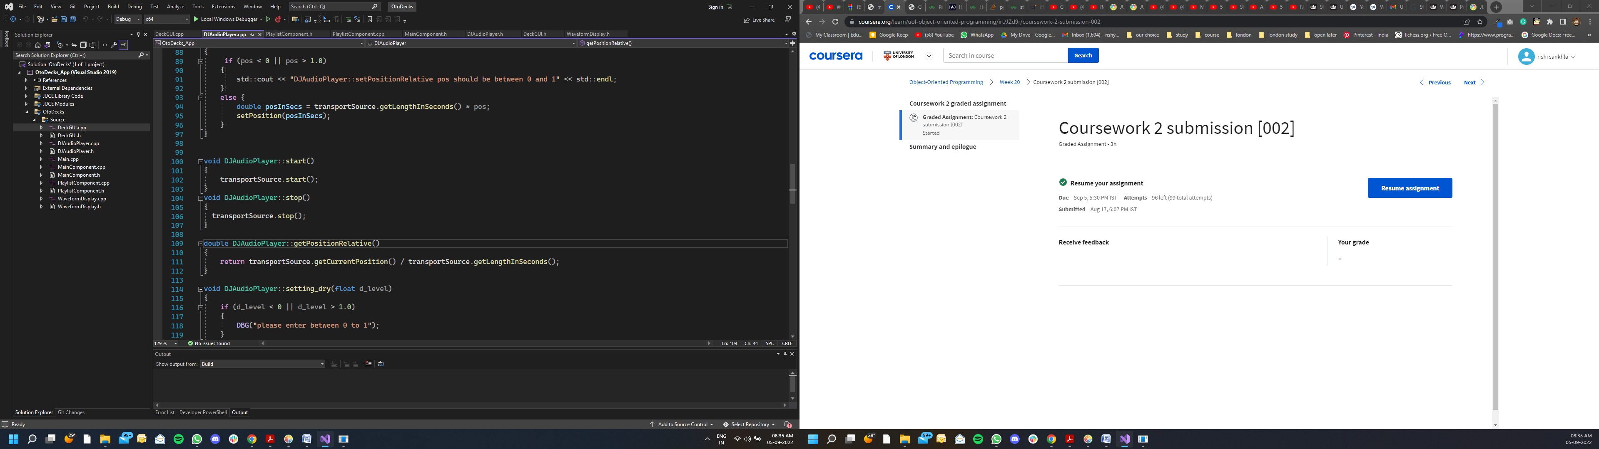

R1C: yes user can mix two tracks by changing their volume slider. Whenever slider value is changed it call the set gain function in DJAudiofile class, As we can see in the below screenshots, which then calls the set gain function of transportSource layer.

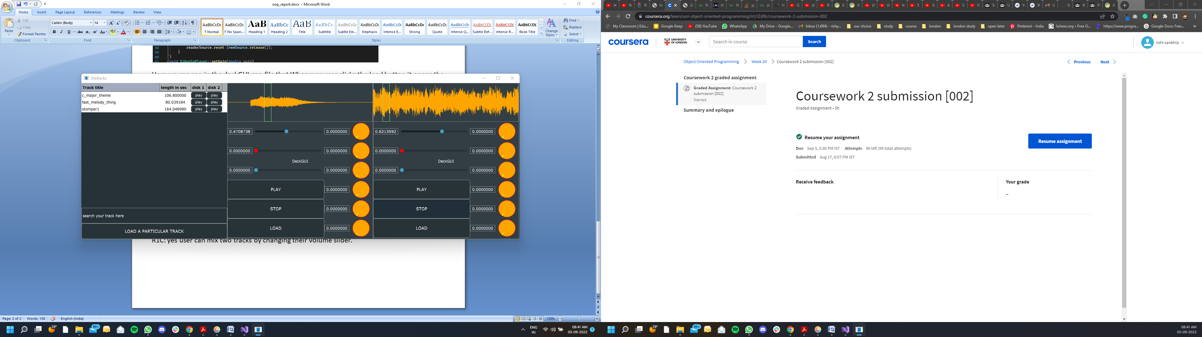

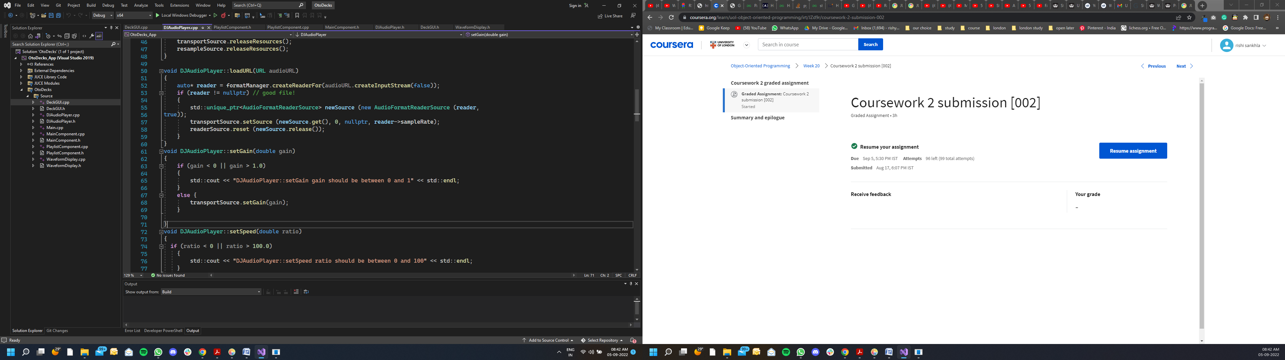

R1D: yes user can speed up or slow down the track using second slider( the one with red color). Here we first call the setspeed function of DJAudiofile class in deckGUI.cpp file, which in the call the setresamplingratio function at resamplesource layer. (refer below screenshot)

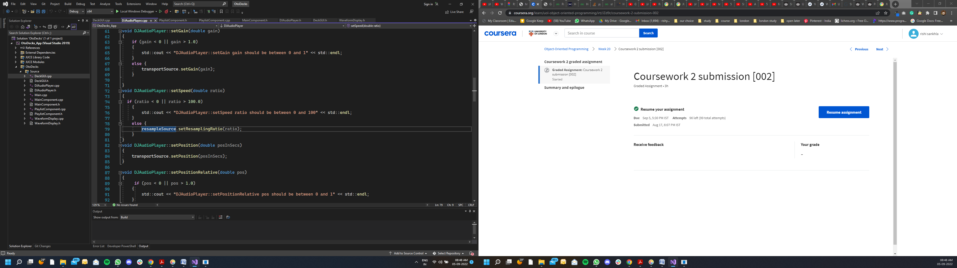

R2A: yes I have implemented custom graphic of my custom component(i.e reverb parameters knobs). I studied the Juce library documentation(reference: <https://docs.juce.com/master/tutorial_look_and_feel_customisation.html> ) and created one more class inside DeckGUI file naming otherlookandfeel, it inherits the juce lookandfeel class.

Then after creating the object of it, inside our DeckGUI.h file, I passed it as a parameter of setlookandfeel function of slider. And also change the slider style to rotary. (check out line 28 in below screenshots)

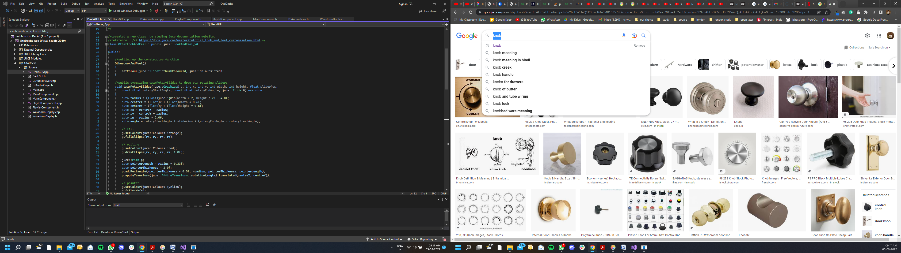

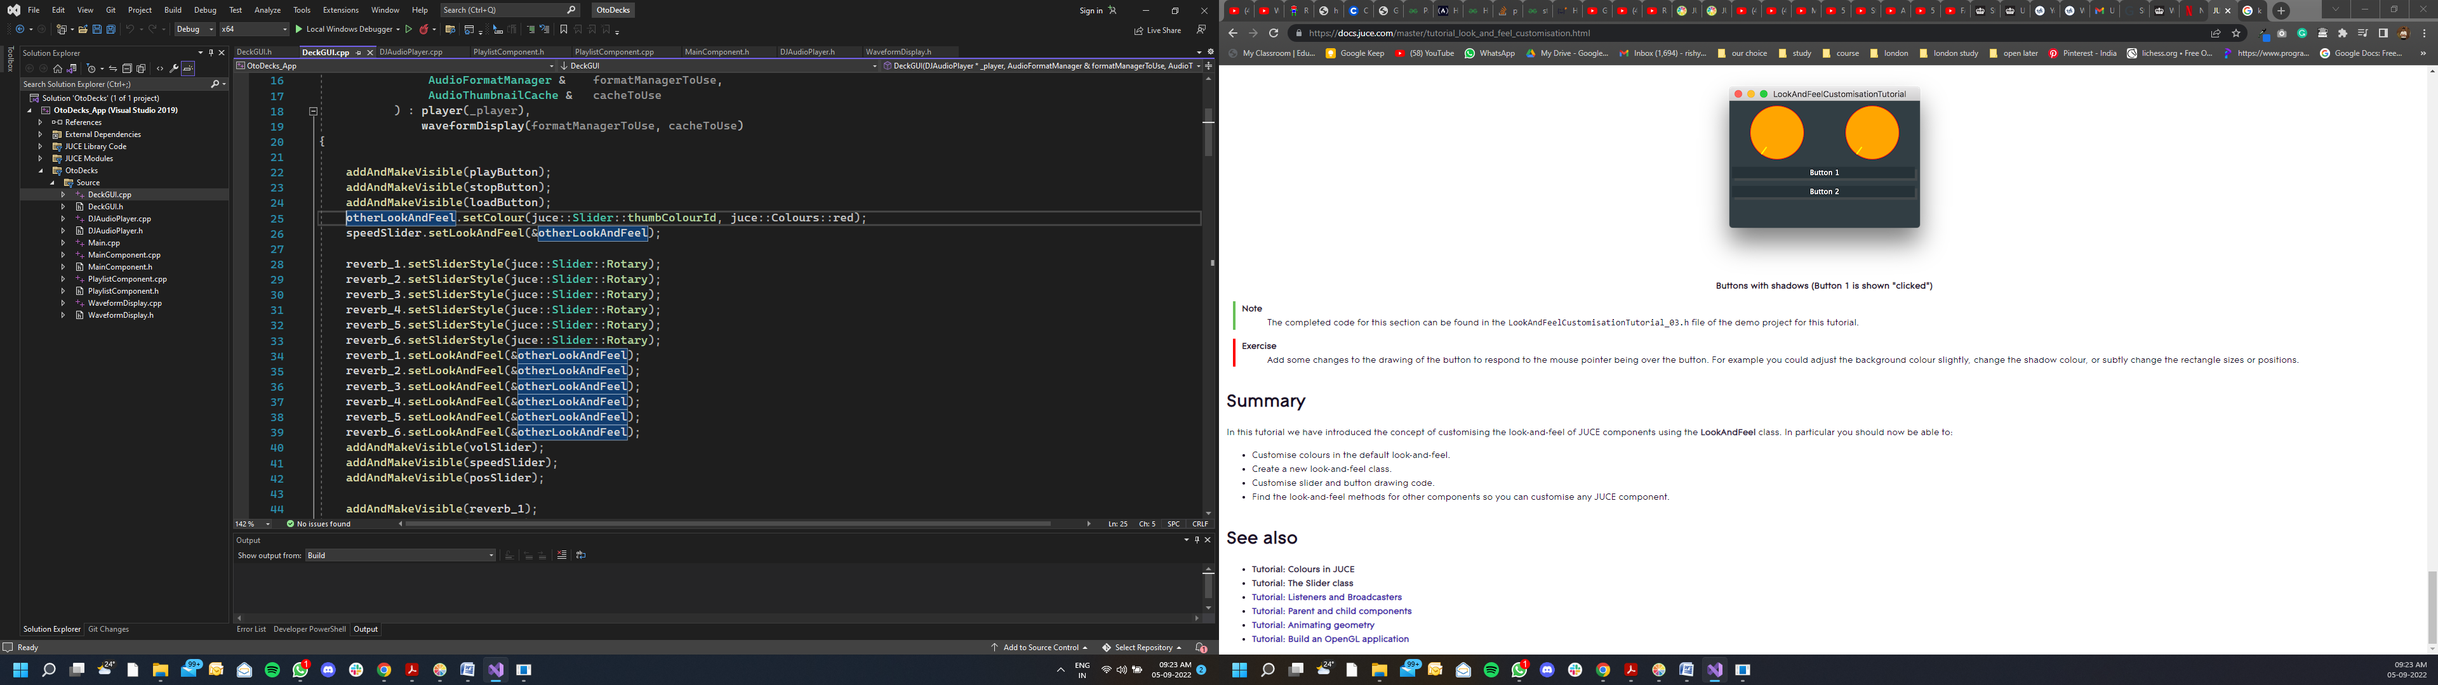

R2B: As we can see In above screenshots my custom deck controls for user are reverb parameter knobs, with the help of them user can not only mix the song effects but can also set the individual 6 arguments of reverb, which are:

our_r_parameter.dryLevel = 0.4f;

our_r_parameter.roomSize = 0.5f;

our_r_parameter.damping = 0.5f;

our_r_parameter.wetLevel = 0.0f;

our_r_parameter.width = 1.0f;

our_r_parameter.freezeMode = 0.0f;

to implement it I first created juce::ReverbAudioSource our_reverb{ &resampleSource, false} and

juce::Reverb::Parameters our_r_parameter; object in the DJAudiofile.h file, now we can change the reverb parameters with the help of our_r_parameter,and the finally pass it to setparameters function of ReverbAudioSource, here ReverbAudioSource replaces the sample layer of our DJ software.

Example function of setting room size reverb-parameter in DJAudiofile.cpp file:

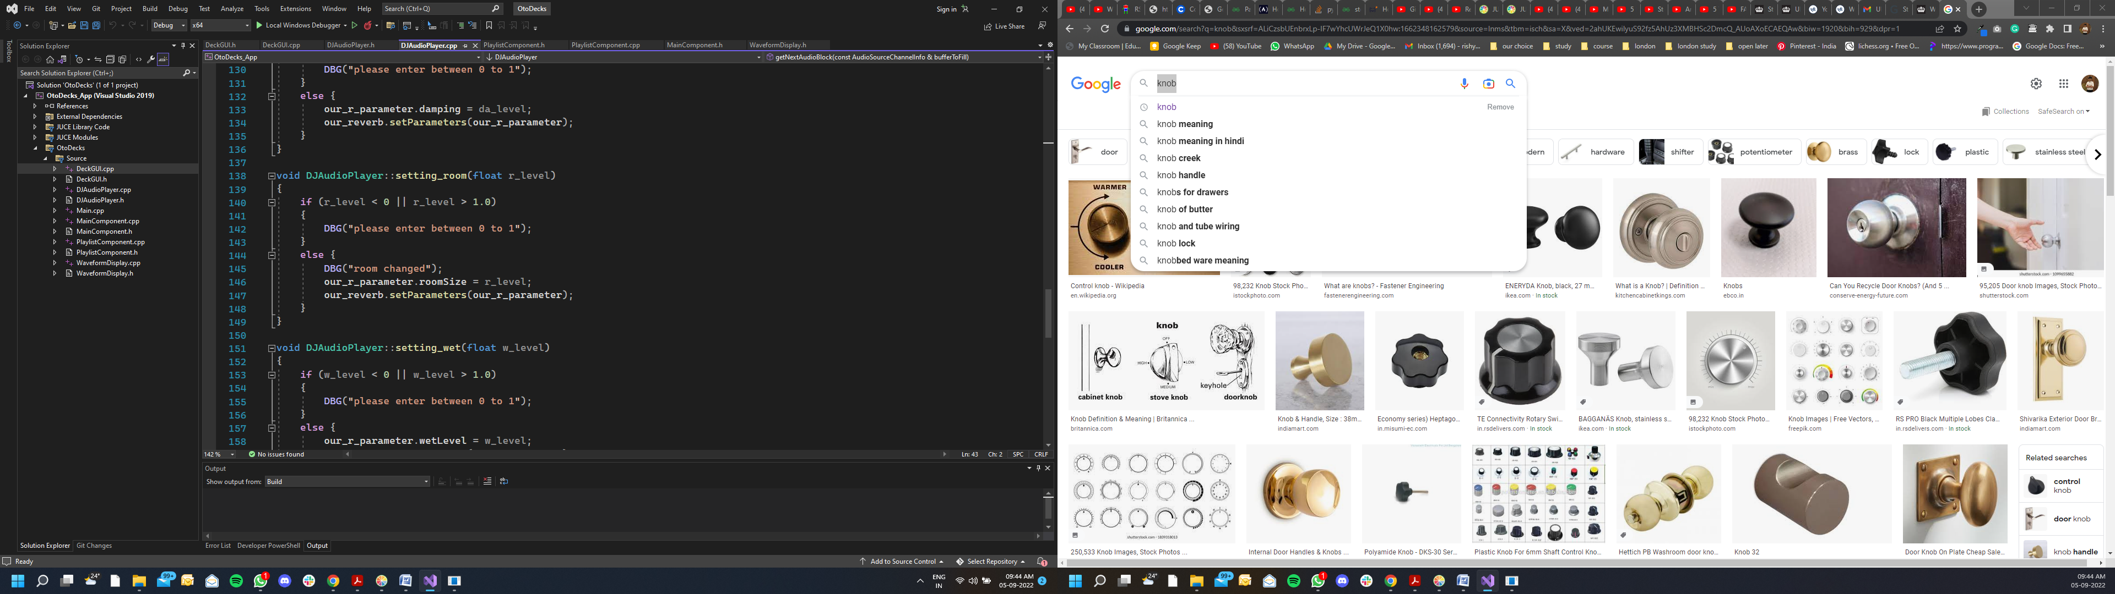

R3A: yes the load button in our playlist allows the user to add any song to our playlist. If user clicks this button, we perform two major task, first it calls the import_library function which open up file browser and load tracks to our playlist by passing the results to select_file function, secondly it updates our table component so that our table reload the data again. (check out below screenshots)

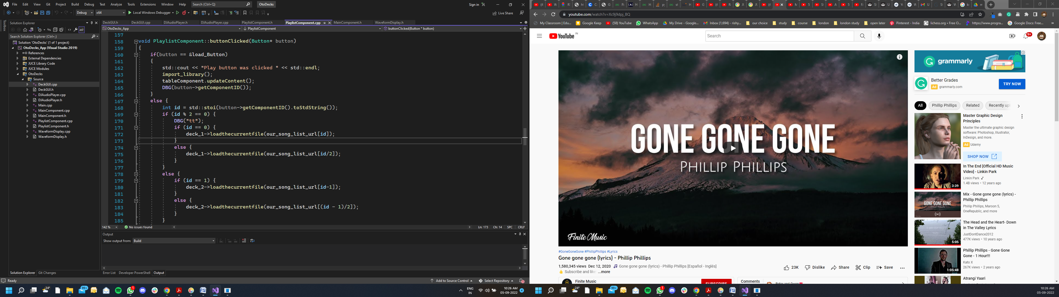

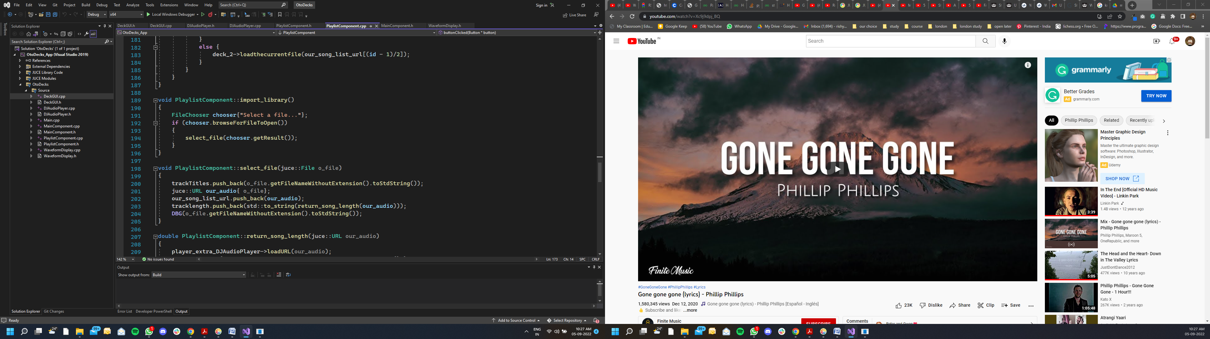

R3B: once we pass the music file to select_file function, it adds the song title, song length and song URL to 3 different vectors. So that in the end we can call updateContent() function of tableComponent to reload the table. To calculate song length, I have created a separate function which passes the song file to a new DJAudiofile instance, to get the length in seconds. (refer below screenshot)

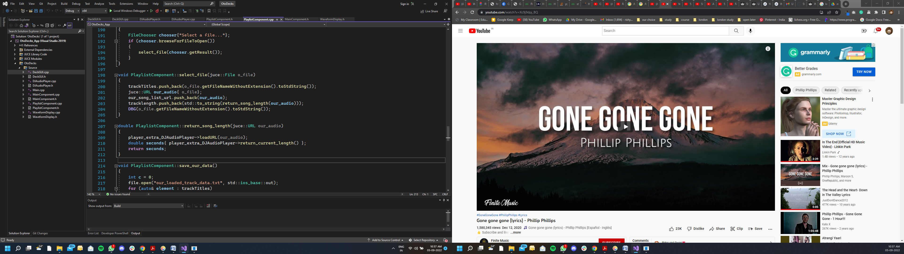

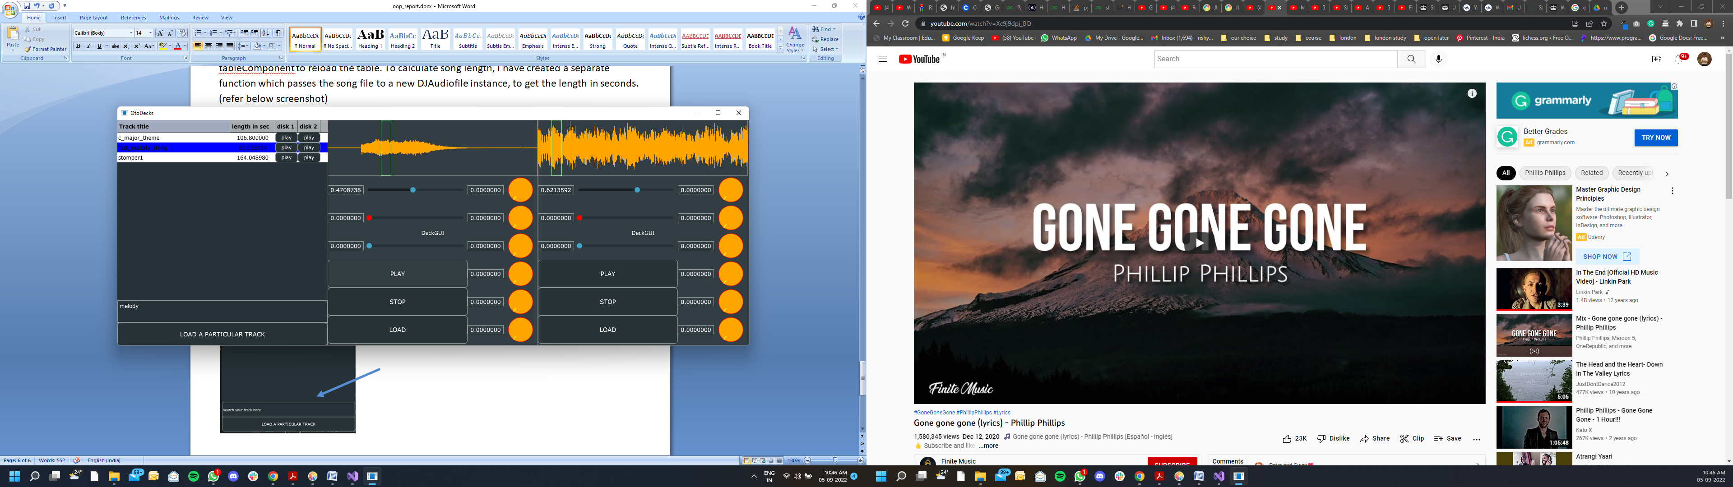R3C: just able the load button I have added a juce text editor to search the song, which perform liner search in the vector containing song title. And then selects the appropriate row.



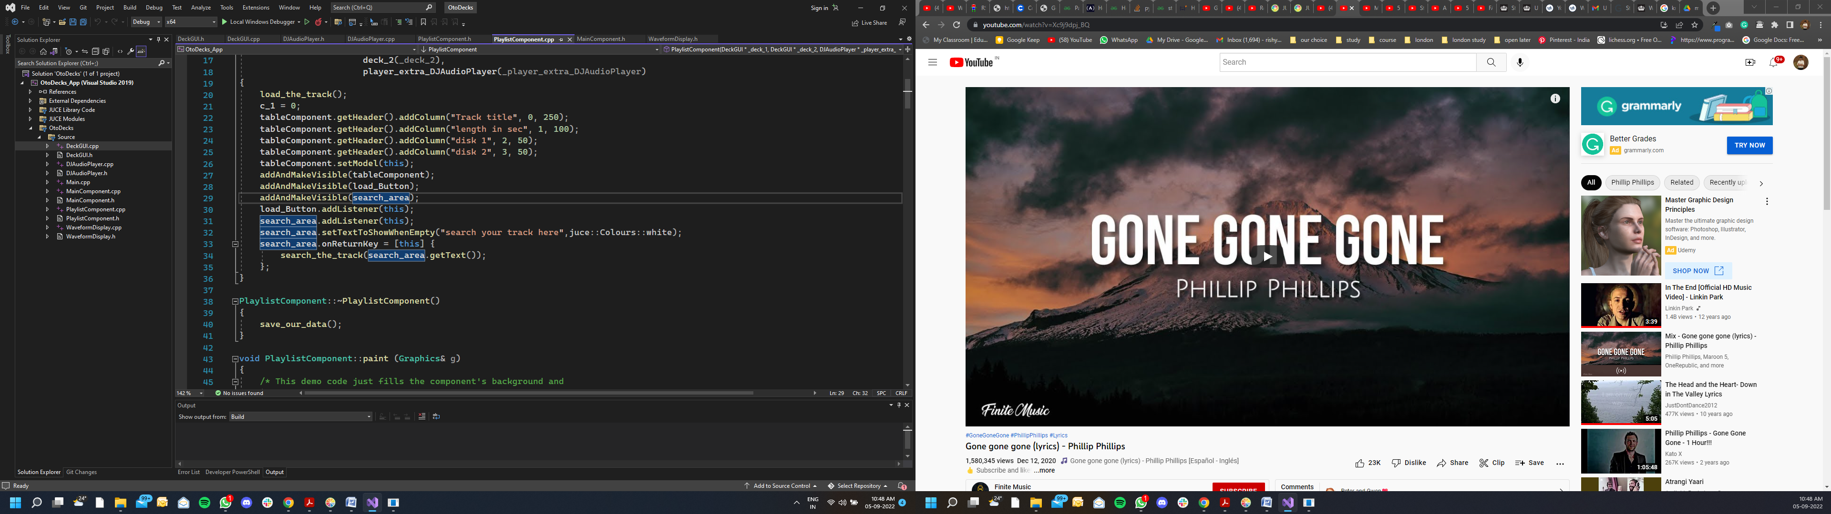

As we can see in the above screenshot of playlistcomponent.cpp file, Once user hits the enter key, text is passed on to search_the_track function, which then perform liner search on our tracktitle vector and finally selects the appropriate row according to the index number. (refer below screenshot of the code)

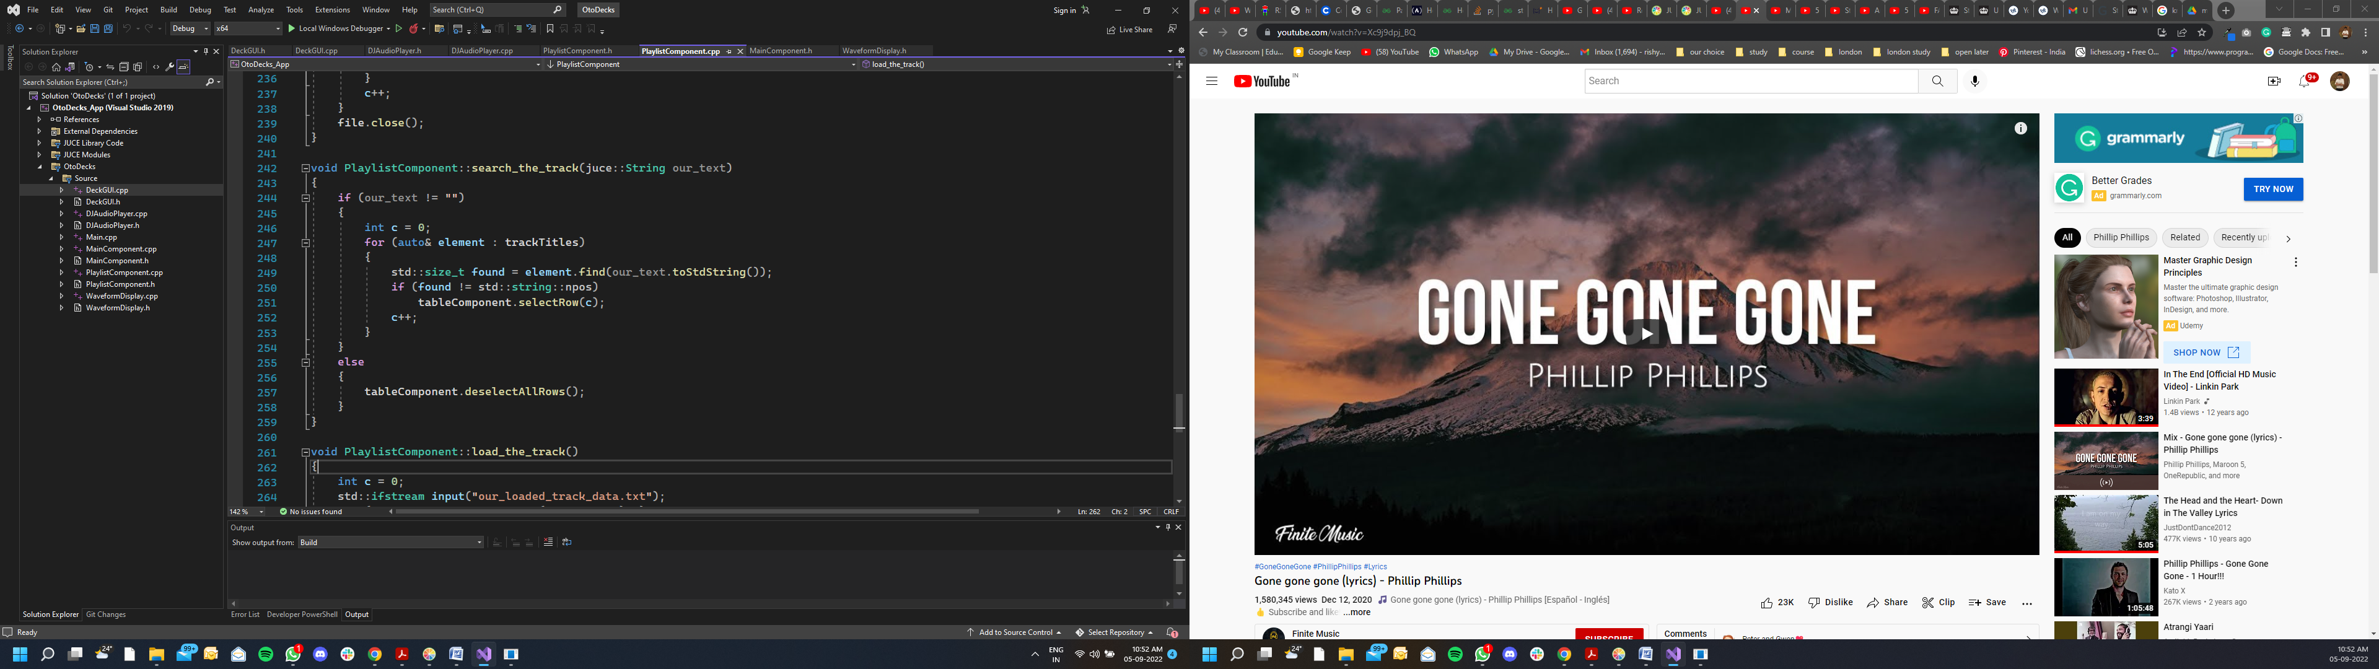

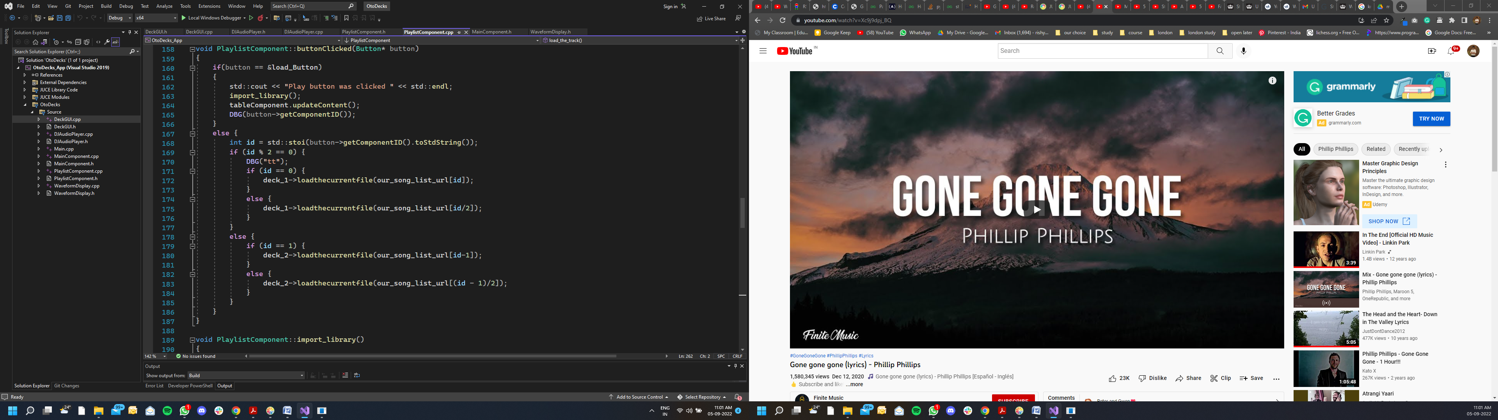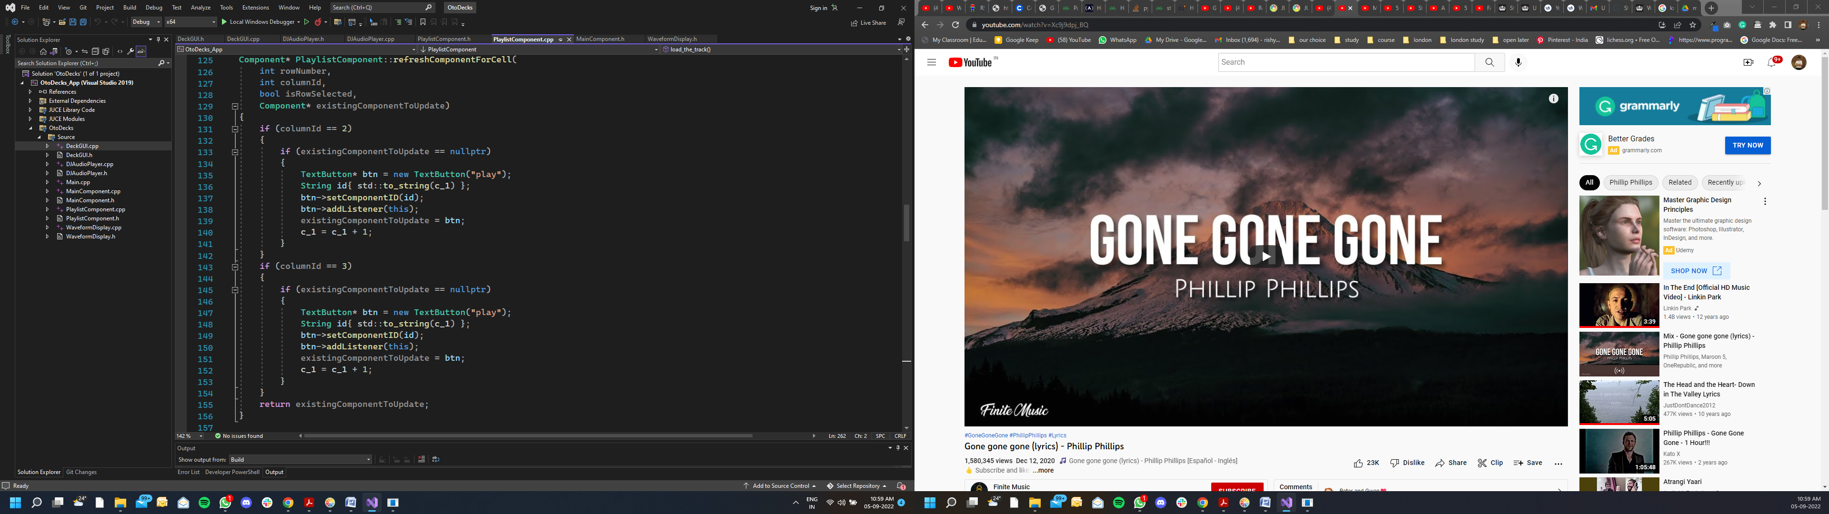R3D: in front of every track there are two buttons, through which user can load any song to our decks. This was possible with the help of juce library refreshcomponentforcell function and buttonclicked function.

Here we are dynamically creating buttons then assigning them index number as ID (refer refreshcomponentforcell function) and then finally adding button listener to them.

In buttonclicked function we first extracts the dynamic button ID and pass on to respected deck to play the particular track (we are selecting song url from the vector according to our ID).

R3E: the music playlist automatically saves all the current track data into a note pad file and then reload it back when application opens up again. And for this mechanism I created two functions, i.e load_the_track (called inside the constructor of playlistcomponent.cpp) and save_our_data (called inside the destructor of playlistcomponent.cpp).

So in save_our_data function we first create the our_loaded_track_data.txt file, add all 3 vectors (track title, track URL and track length) data in it, then finally close the file.

Whereas, in the load_the_track function we read our our_loaded_track_data.txt file and copy it back to our vectors. And finally calling updatecontent function to reload our table. (refer below screenshots)

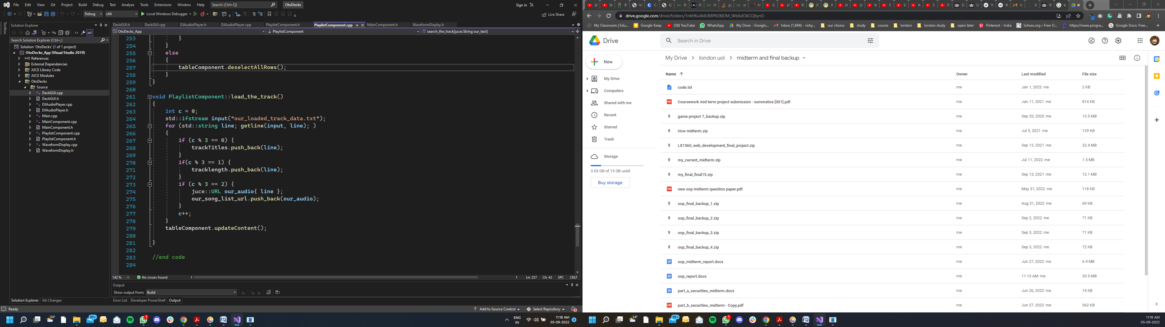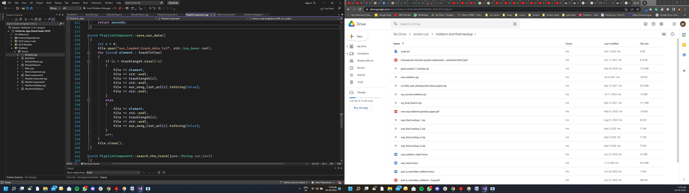

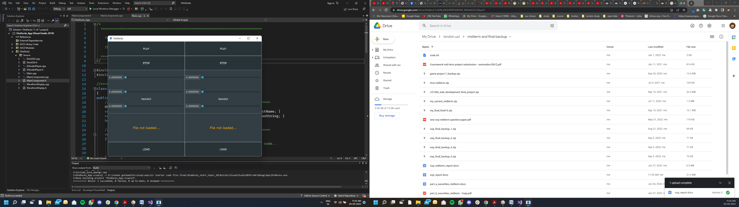R4A: as we can see from the below screenshots that there’s a significant difference between DeckGUI shown in class and the one I made.



To change layout, I first reoriented my playlist to left in the maincomponent.cpp file and also changed the default screen size to 1400 width and 500 height.

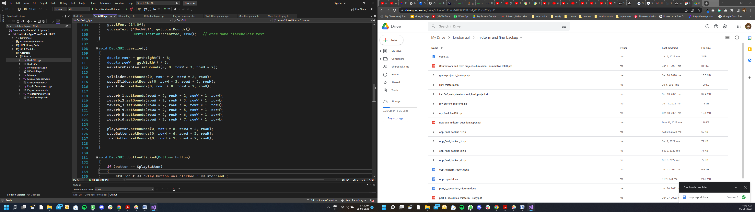

Then I rewrite both the resized function (one in DeckGUI and one in playlistcomponent) and also added the extension components in it, i.e reverb knobs, search button and load button for playlist.

R4B: as we can see in the above screenshot from DeckGUI file, my DJ app GUI includes the custom reverb parameters knobs. And with help of lookandfeel class I was able to implement custom graphics on it. By changing style to rotary and color to orange.

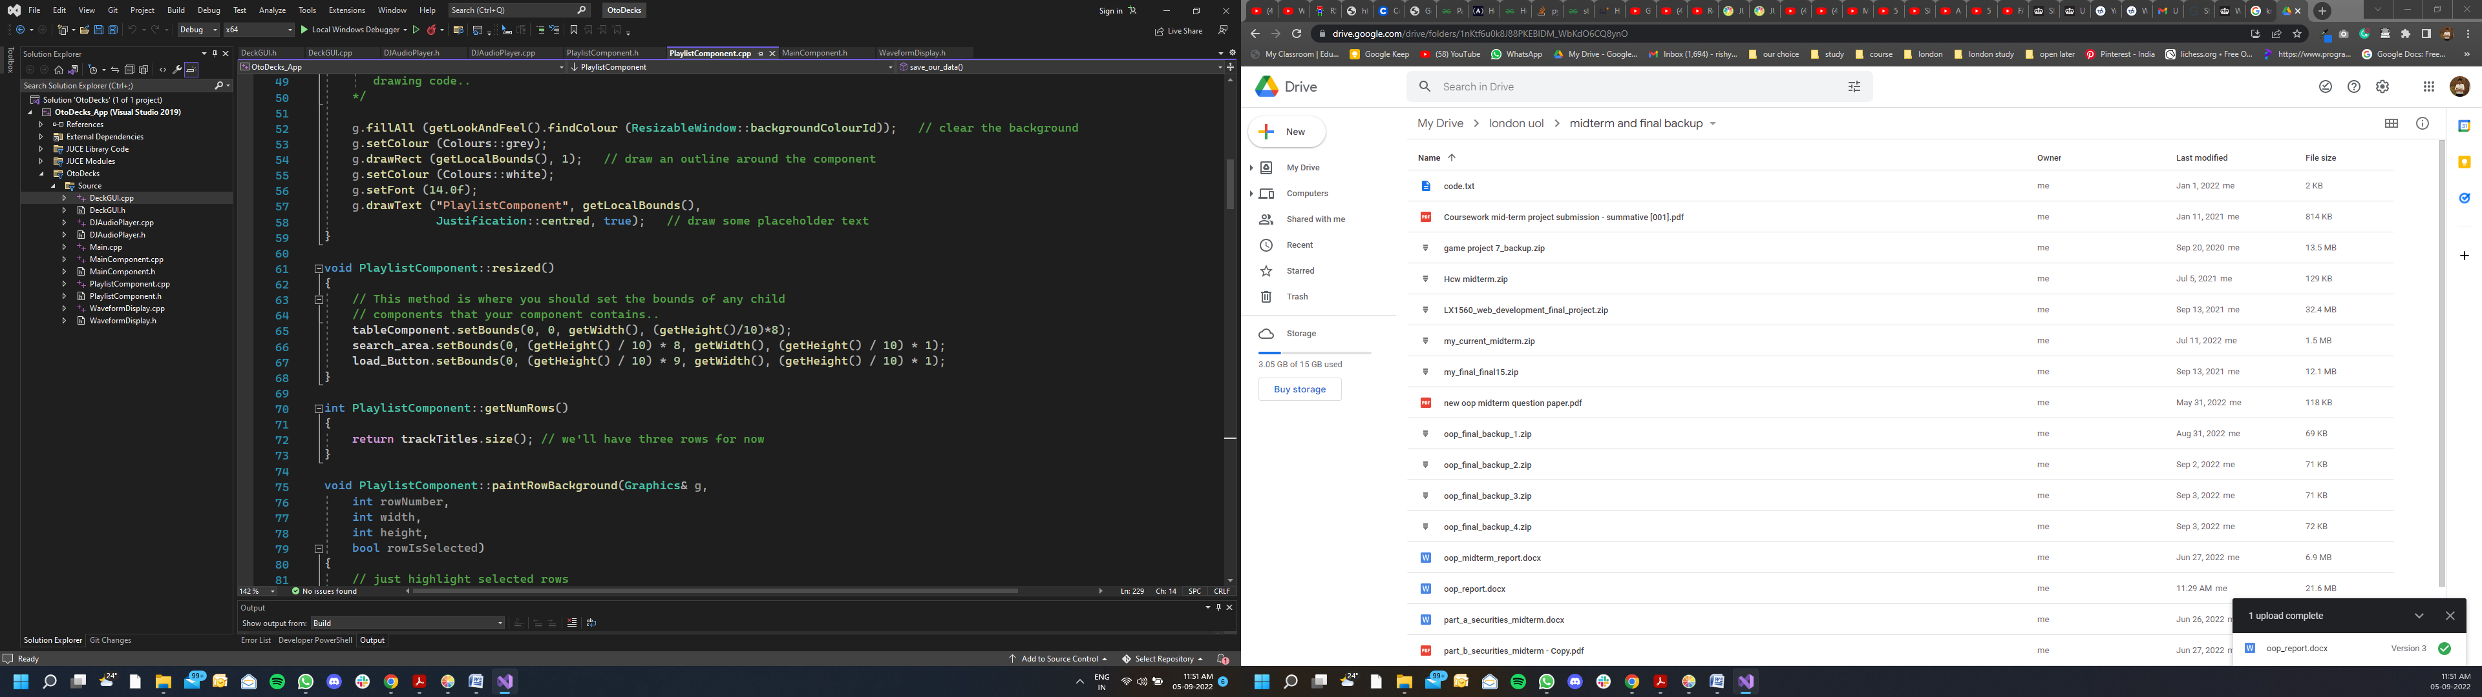R4C: as we can see in the below screenshot from playlistcomponent file, my DJ app GUI contains the playlist as a component, which not only contain tablecomponent but also have the search editor & file load button.

I changed the table dimensions, edited the paintrowbackground function and pain function to change the color of row when selected or deselected.